Course project MLT 2025
"The study of the comparative efficiency of machine learning algorithms in solving specific problem"
(result - report)
- Select a task:
Choose a topic according to the theme of your Master research in the University (preferable) or select from the list below:
https://www.kaggle.com/datasets/hojjatk/mnist-dataset
https://www.kaggle.com/datasets/janiobachmann/bank-marketing-dataset
https://www.kaggle.com/c/walmart-recruiting-store-sales-forecasting/data
https://www.kaggle.com/c/rossmann-store-sales/data
2. Build a mathematical formalization of the problem (loss function, optimization algorithm etc.)
3. Describe the quality metric(s) by which the solution of the problem can be assessed.
4. Select at least 3 methods / algorithms of machine learning to study the comparative effectiveness of the methods of solving the task.
5. Compare the quality of algorithms with respect to the chosen metric(s).
6. Make a conclusion about which algorithm gives the best results for the task (and why).
7. Report form:
Report in English 5-10 pages (introduction, related works, problem statement, description of methods, data processing, experiments, conclusion).
Template is on the following pages.

Ministry of Science and Higher education
of the Russian Federation
ITMO University

Faculty of Digital Transformations
Subject area (major) 01.04.02. Applied mathematics and informatics

REPORT
(report title)

Student: Ivanov Ivan C42111c
Supervisor: Gladilin P.E. – or your research supervisor

Date 23.03.2024

St. Petersburg
2024

TABLE OF CONTENT
1. Introduction 5
2. Overview 5
3. Models and Algorithms 5
4. Experimental research 5
5. Conclusions 5
References (example) 6

- Introduction
XXX
- Literature review
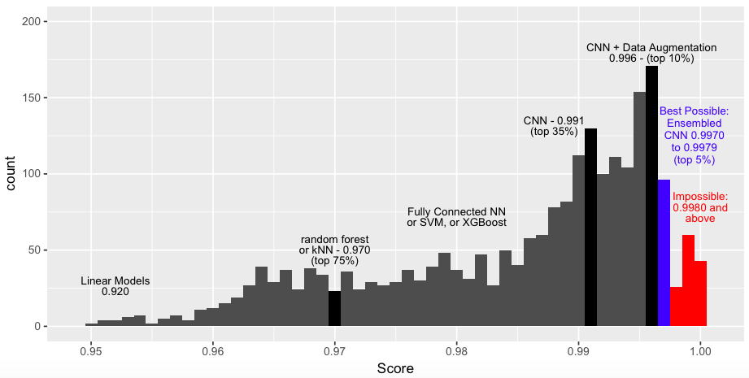
Figure 1 – (example of the figure caption) Kaggle MNIST public leaderboards scores, July 15 2018
- Models, Algorithms and Datasets
- Experimental research
XXX
Table 1 – (example of the figure caption) CNN-5 results
Submission and description | Private | Public
cnn-5-baseline | 0.075 | 0.089
cnn5_balanced | 0.006 | 0.009
cnn5_balanced_20ep | 0.010 | 0.010
cnn5_balanced_20ep_undersampling (16x16) | 0.010 | 0.012
cnn5_64x64_balaced_20ep_undersampling | 0.046 | 0.050

- Conclusions
XXX
References (example)
1. Tan M., Le Q. V. EfficientNet: Rethinking model scaling for convolutional neural networks // 36th Int. Conf. Mach. Learn. ICML 2019. 2019. Vol. 2019-June. P. 10691–10700.
2. Huang G. et al. Densely connected convolutional networks // Proc. - 30th IEEE Conf. Comput. Vis. Pattern Recognition, CVPR 2017. 2017. Vol. 2017-January. P. 2261–2269.
3. Yun S. et al. CutMix: Regularization Strategy to Train Strong Classifiers with Localizable Features. 2019.
4. Zhang H. et al. MixUp: Beyond empirical risk minimization // 6th Int. Conf. Learn. Represent. ICLR 2018 - Conf. Track Proc. 2018. P. 1–13.
5. Zoph B. et al. Learning Transferable Architectures for Scalable Image Recognition // Proc. IEEE Comput. Soc. Conf. Comput. Vis. Pattern Recognit. 2018. P. 8697–8710.

